/*

stars.txt contains a star catalog:

* x, y and z coordinates.

- Each axis goes from -1 to +1, center at 0,0.

* Henry Draper number, a unique identifier for the star.

* The magnitude (or brightness) of the star.

* The Harvard Revised number, another identifier.

* The seventh field exists only for a small number of stars

and is a semicolon-separated list of names for a star.

- A star may have several names.

*/

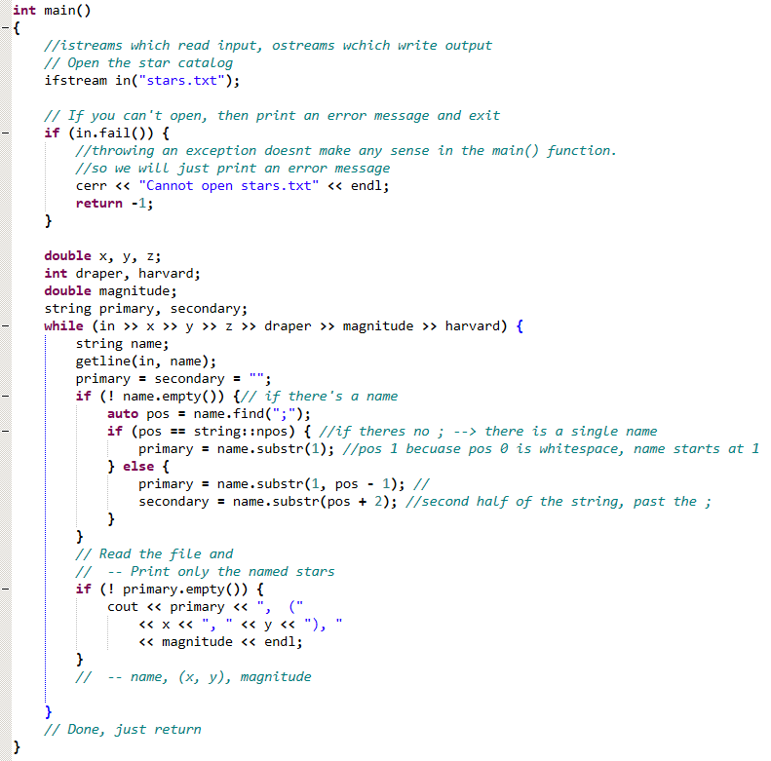

Parsing stars file (without structures)

And WITH structures:

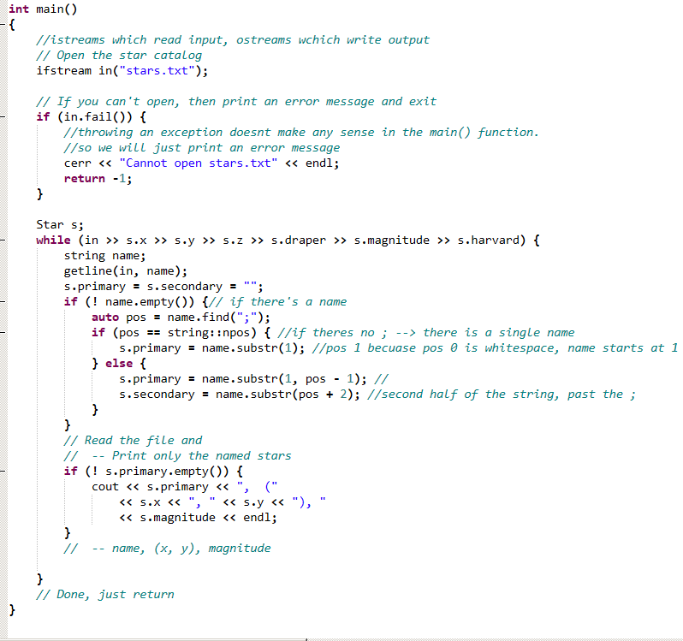

Struct Star in the header file: 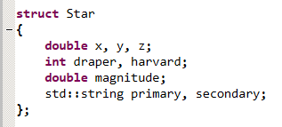

Same thing, with structures, functions, AND overloaded operators

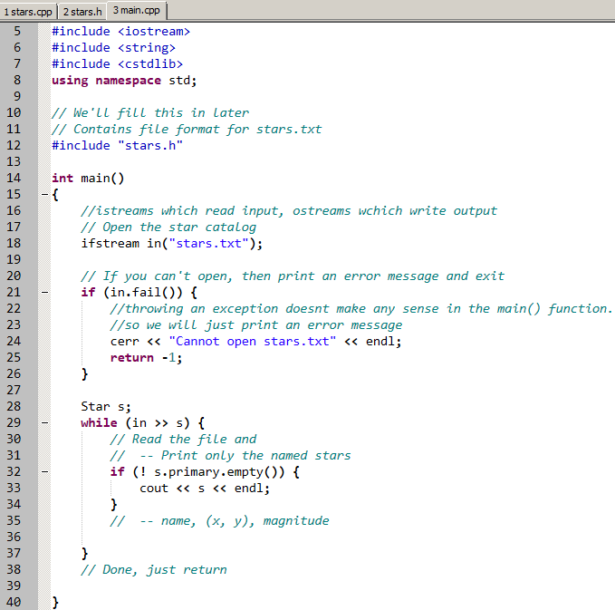

Stars.cpp:

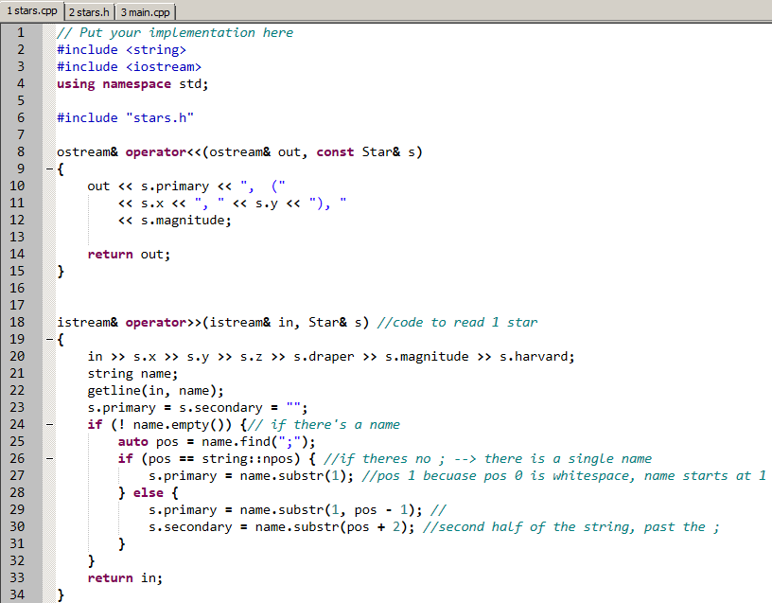

Stars.h:

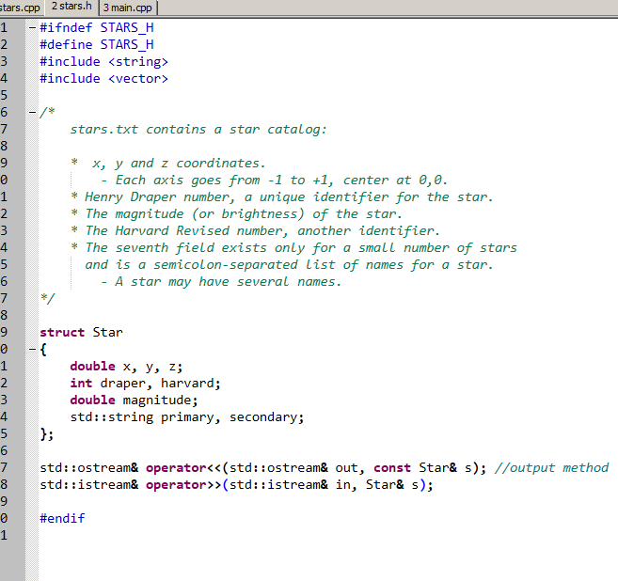

____________

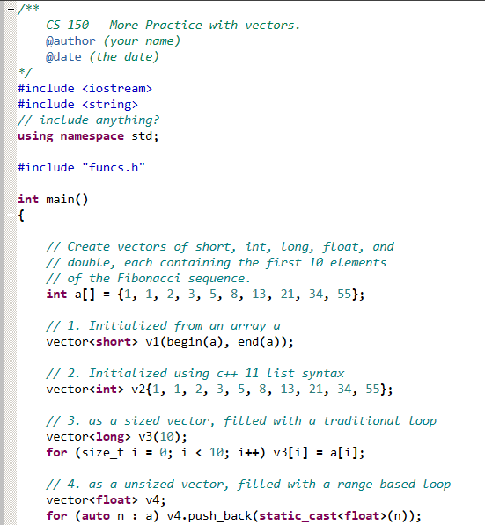

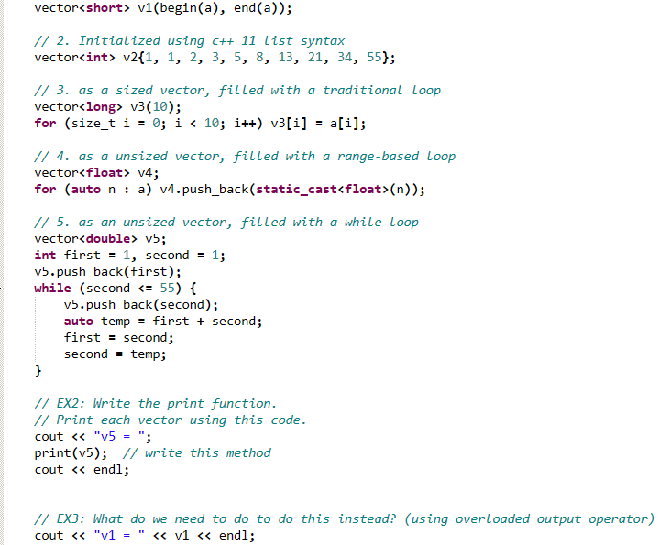

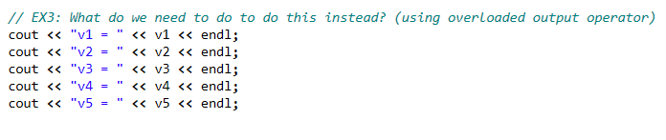

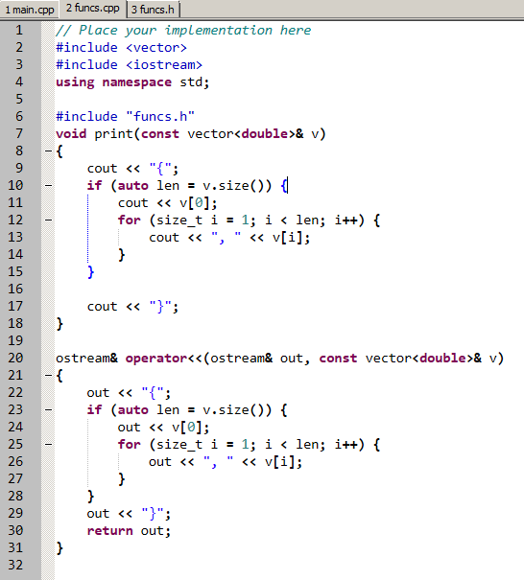

Crazy generic function :

